**Assignment – 11**

Name- Yashraj Ranjeet Shitole

Roll no. - 86633

1) Write a query that uses a subquery to obtain all orders for the customer named Cisneros. Assume you do not know his customer number (cnum).

**Select orders.onum, customers.cname, orders.amt, orders.odate, orders.cnum, orders.snum from orders , customers where orders.cnum=customers.cnum and customers.cname='Cisneros';**

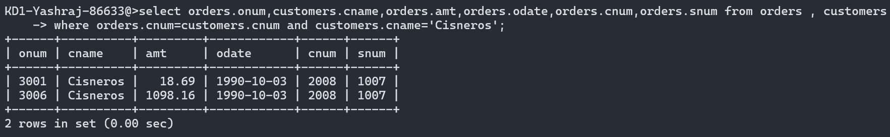

2) Write a query that produces the names and ratings of all customers who have above-average orders

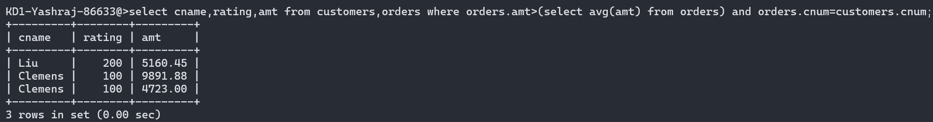

3) Write a query that selects the total amount in orders for each salesperson for whom this total is greater than the amount of the largest order in the table.

**select sum(amt) from orders,salespeople where orders.snum=salespeople.snum group by orders.snum having sum(amt)>(select max(amt) from orders);**

